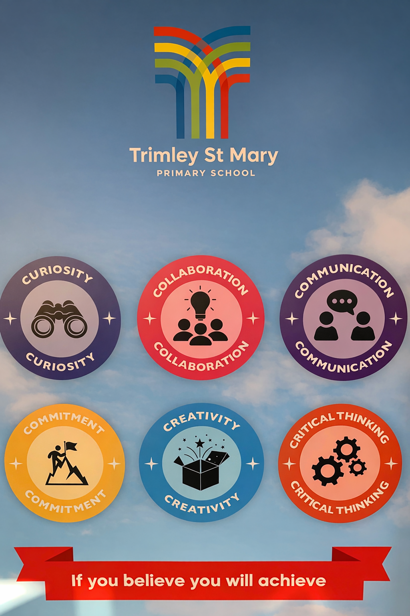

Our Vision
Learning Together. Thriving Together. Achieving Together.
Our values are inspired by the 6 Cs.

