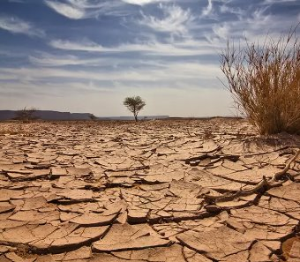 Parent leaflet: Summer 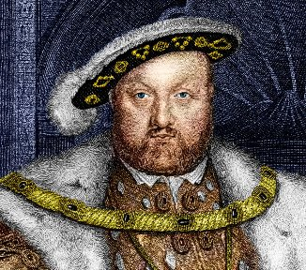
Class: Birch and Pine
Our Topics: History: What was life like in Tudor England?
Geography: Would you like to live in the desert?
Our learning this half term:  - To continue to follow our progression in maths.  - Recall multiplications in any order.  - Immersing ourselves in our chosen texts and short films – One Small Step and Mars Transmission. Writing a variety of genres – e.g. stories, diary entries, letters, descriptive writing and factual pieces etc.  - Learning about the Tudors and what life was like in Tudor England.  - Understanding what biome deserts are and how they are used.  - Continuing to explore the French language through speaking, listening and writing.  - Create artwork inspired by the Tudors and deserts.  - Learning about space, forces and humans.  - Learning to create our own games in computing. | Ongoing learning:  - Guided reading sessions.  - Learning spellings.  - Handwriting – letter formation / fluent cursive script.  - Learning times tables.  - Grammar – to develop using parenthesis, semi-colons and colons in our work.
Key Dates or things to remember:
PE kits are needed every Tuesday.

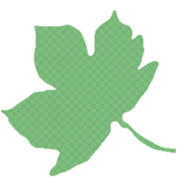
LIBRARY
Year 5 – Monday
Wild Wednesday Dates
Wednesday 4th June – Year 5

Wednesday 9th July – Year 5

Dates will be sent via ParentMail as a reminder. Please remember to send your child in with appropriate clothing for the weather (e.g. sweatshirts, jogging bottoms, wellies, waterproofs etc).
Useful ways to support learning at home:
Reading challenge: reading for 5 minutes 5 times a week, giving your slip in on a Friday.
Maths: MyMaths set weekly. There are lots of maths games to explore too.
Spellings: Spellings are set every Friday on Purple Mash.

